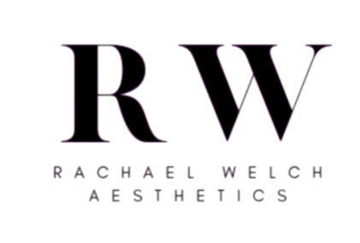

Privacy Policy
Rachael Welch Aesthetics is committed to protecting your privacy and ensuring that your personal data is handled safely and responsibly.

Who We Are
Rachael Welch Aesthetics provides aesthetic treatments and skincare services. This privacy policy explains how we collect, use, and protect any personal information that you provide when using our website or contacting the clinic.

What Information We Collect
We may collect and process the following information:
- Name
- Contact information such as email address and phone number
- Information provided through contact forms or booking enquiries
- Medical information relevant to treatment consultations
- Website usage information through cookies and analytics tools

How We Use Your Information
Your information may be used for the following purposes:
- To respond to enquiries and appointment requests
- To provide consultations and treatments safely
- To maintain accurate treatment records
- To improve our website and services
- To communicate important information regarding appointments or treatments
- We will only use your personal data where it is necessary and lawful to do so.

Medical Information
Any medical or health information provided during consultations or treatment forms is considered sensitive personal data and is handled with strict confidentiality in accordance with UK data protection laws.

How Your Data Is Stored
Your personal information is stored securely and only kept for as long as necessary to provide services and comply with legal or insurance requirements.

Sharing Your Information
We do not sell or share your personal information with third parties for marketing purposes.
Information may only be shared where necessary, for example:
- With secure booking or payment systems
- Where required by law
- With insurance providers if required for professional purposes

Cookies
Our website may use cookies to improve your browsing experience and understand how visitors use the site. You can choose to disable cookies through your browser settings.

Your Rights
Under UK data protection law, you have the right to:
- Request access to the personal data we hold about you
- Request correction of inaccurate information
- Request deletion of your data where appropriate
- Withdraw consent where processing is based on consent

Contact
If you have any questions about this privacy policy or how your data is handled, please contact:
Rachael Welch Aesthetics
Email: info@rachaelwelchaesthetics.com
Phone: 07817965048

